***Illustration Instructions:***

The instructor will give a demo of some tips for illustration and using watercolor pencils after talking about scientific illustration.

Drawings based on observation require you to **Look** **CLOSELY**! One of the most important things about drawing is to look closely at what you are drawing, sometimes even more than the drawing itself.

**Notice.** Notice what shapes you see in what you are looking at. This is a really good way to break down complex forms. Draw the individual shapes separately to make up a whole. For instance if the cells you observe are oval with small shapes inside, draw the big oval first then the small shapes inside. It is usually helpful to draw the larger overall shapes first. Here is an example of drawing an animals face using simple shapes.

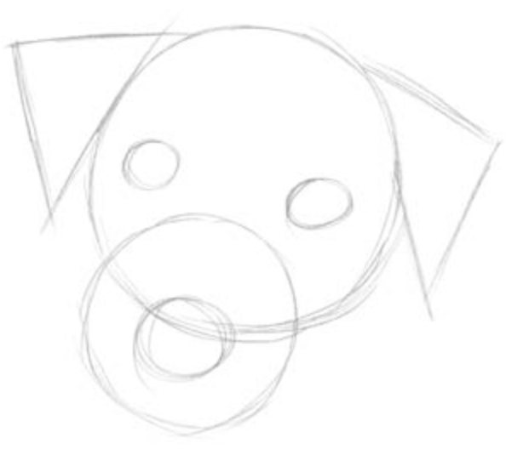

**Shading** - if you want to shade there are a few techniques to try. **Note: If you are planning on painting or using the watercolor pencils to color your drawing in, you may not want to shade in your drawing as it may smudge and make the color look ‘dirty’

1. Shading with the side of your pencil - pressing down hard then slowly lighten up the pressure. This gives a dark to light effect

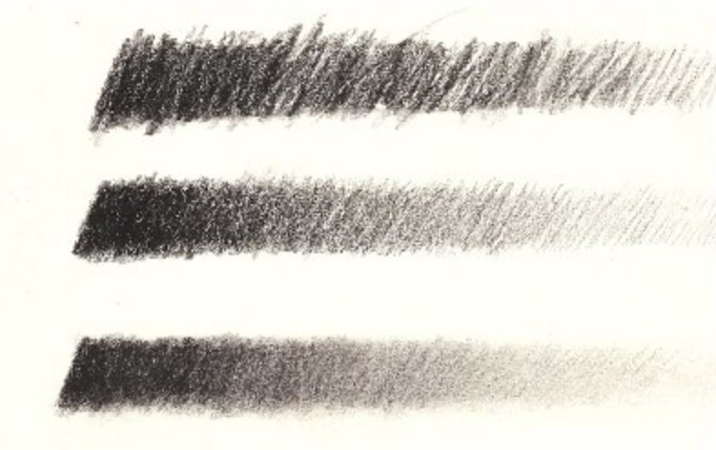

1. Crosshatch. This technique is making lines that cross over one another repeatedly to create a darkness.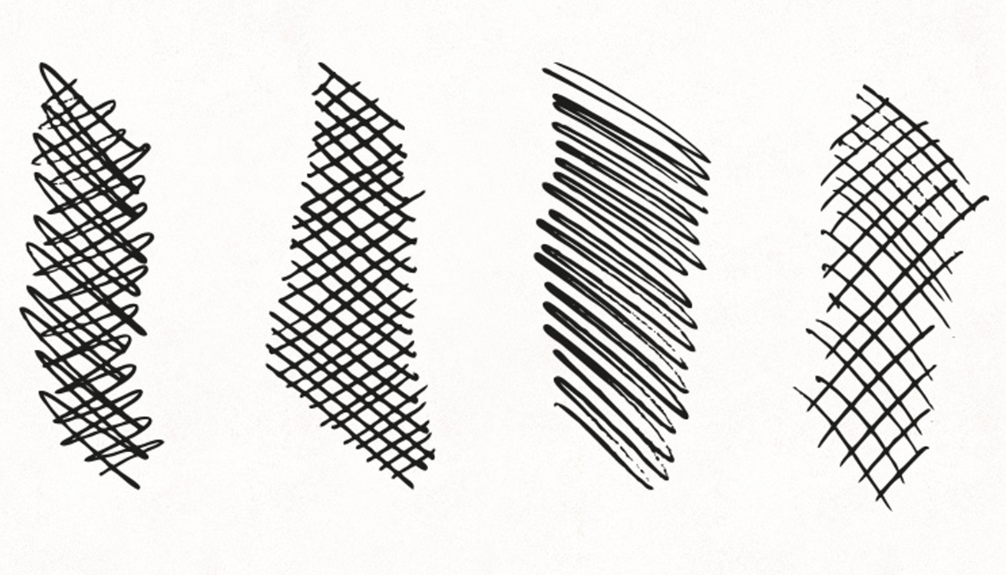

3. Contour crossing

If the subject that you are drawing is curved, draw curved lines to help make the object more three-dimensional

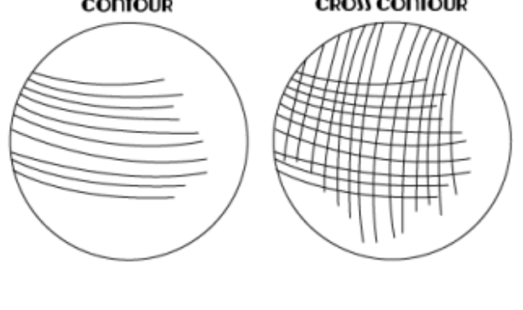

**Watercolor pencils**

Watercolor pencils are a great way to explore color through traditional color pencils and to take it to the next stage of watercolor. Have the instructor demonstrate some of the following techniques. *If using watercolor pencils, it is recommended to use watercolor paper.

There are several ways to use watercolor pencils:

1. Don’t use any water and use them like you would regular colored pencils
2. Dip them in water and draw with them
3. Use them like regular colored pencils and then paint over them with a water-filled brush and they will react like regular watercolor paints
4. Wet the paper first and then draw with the watercolor pencils
5. Mix two colors together while dry and then go over with a water-filled brush - this creates a mixed color. For instance, yellow and blue will create a green color.

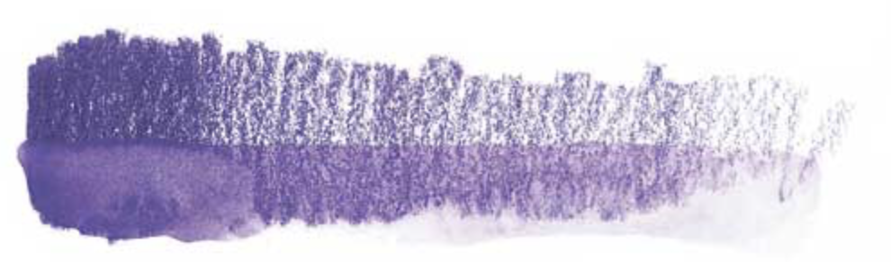

*Example of a dry watercolor pencil, transitioning to wet*